


How-to use model templates for diagram creation

Date: | 09/11/09
Editor | Javier Cano
Status | Draft Version
Version number | 1

Authors
Editor | E-mail
Francisco Javier Cano (Prodevelop) | fjcano@prodevelop.es

Authors | E-mail
Francisco Javier Cano (Prodevelop) | fjcano@prodevelop.es

Revision chart and history log

Version | Date | Reason
1 | 09/11/09 | Initial version

Model templates
A new extension point is available in the 'org.eclipse.papyrus.wizards' plugin that allows the definition of model templates to be used in the papyrus model creation.
The 'Template' element in the extension point has this structure:
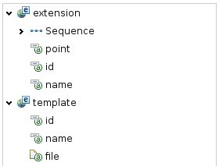
The attributes of the template element have this meaning:
- id: identifier of this template contribution.
- name: the name with which this contribution wil be shown.
- file: URL pointing to the model template file inside the plugin.
The model template file has to be contained in the same plugin that is using the extension point so that it can be correctly located.
The model creation wizard will show all the template models that are contributed to this extension point and if one of those templates is chosen, the created model will be initialized with the contents of the selectd template.

Example
Here is an example of the new template selection wizard page with a template contributed from the MOSKitt gvMetrica methodology:
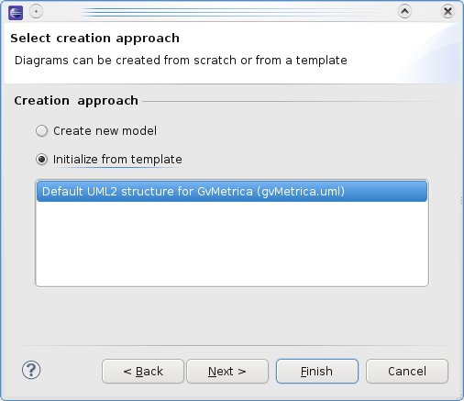
And the resulting model that has been initialized with the contents of the model template:
